**ANALYSIS REPORT**

**Name:** Syed Muhammad Faizan **Roll no:**21L-5675

**Section:**BDS-3B

1. The dataset I am using is
2. Spending score of customers
3. Annual income

And the source for it is kaggle(https://www.kaggle.com/datasets/sindraanthony9985/marketing-data-for-a-supermarket-in-united-states).

1. Parameters for k-means are 3.

Visual aid:

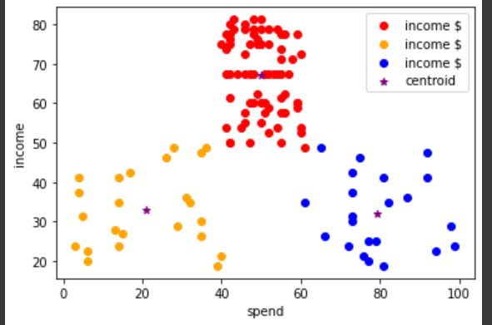

1. The algorithm I have I choosen **is DBSCAN**.

Eps = 4

Min samples = 3

Which are devised by using elbow method.

Using the value of k and k-1

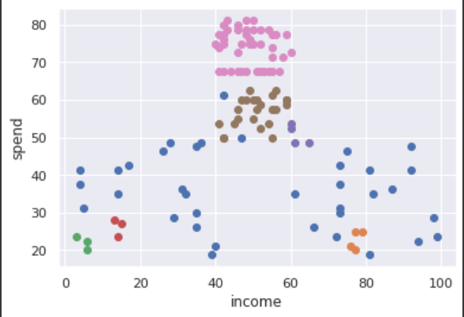

1. K-means would be more preferable as we compare the pictures form both part b and c .We would notice that the result from k-means is very much clear and understandable as compared to DBSCAN. K-means gave us better and more accurate clusters as compared to DBSCAN.k-mean is very much faster because it has clusters , centeroid to distinguish ,to identify quickly whereas the graph from part above part c is isn’t showing clusters and is very difficult to understand.